TORY BURCH FOUNDATION

EXECUTIVE SUMMARY BUILDER
Welcome to the Executive Summary Builder. This is a template for a one-page document of essential information that you can share with potential stakeholders in order to help them make decisions.

Instructions
This is a read-only template document. In order to make this document your own, make a copy to your computer. The Tory Burch Foundation will not have access to your business plan; you will be the sole owner.

- Open the Microsoft Word template you want to use.
- Go to File, then Save as. Your editable copy will download automatically. Open your saved file and start editing.
- Be sure to save your progress as you go.

Use the writing prompts and relevant content linked in the sections to help you write your business plan.

Customized Examples
View examples of this template customized in Google Docs

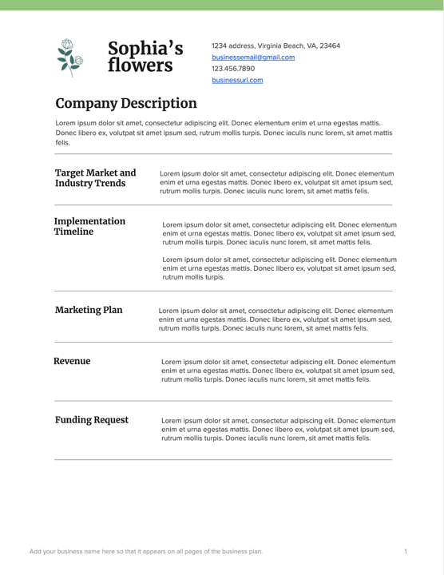  View example | 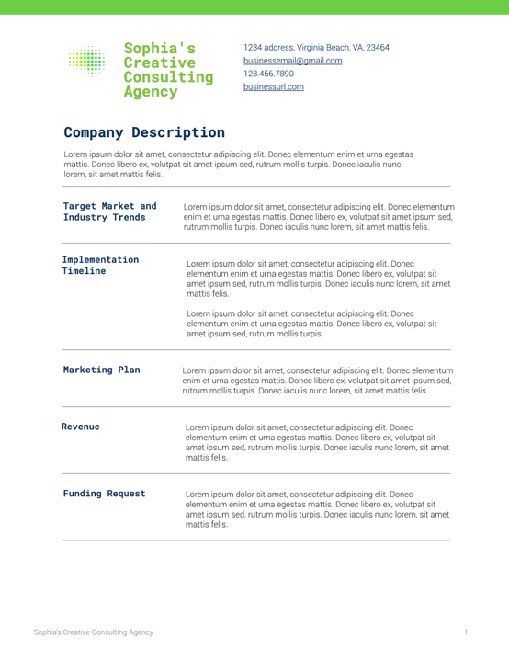  View example

Tips & Tricks
- How to paste text and match established formatting
  - Select the text you want to replace.
  - Click the drop down Edit, then Paste and Match Formatting.

- How to edit heading and paragraph font styles. Make the desired type style edits to font choice, size, color to selected text. This will change each instance of these styles throughout the document.
  - Click Home and then click Styles Pane to view all global type styles.
  - Click the caret next to the style you would like to update, then Modify Style to edit the type style globally.

- How to insert a section break
  - Go to the end of the text you want to insert the break.
  - Click Insert, then Page Break.

- How to delete a section break
  - Select Home, then Show/Hide to show section breaks.
  - If on a Mac computer, place your cursor in front of the section break. Then, press fn + Delete.
  - If on a Windows computer, place your cursor on the line directly above the section break. Then, press Delete.

- How to insert images
  - Right-click an image container and select Change Picture.

- How to resize the bounding box/crop of an image
  - Double-click on the image element and update the outlined toggles.

- How to add more team members
  - The team members section is a table.
  - View the boundaries of the table by clicking in the top left corner. With the table highlighted right-click and select Table Properties.
  - Add a border to the table to see the boundaries of the table.

  - Right-click in this section and select Insert, then Rows Below.

- How to remove team members
  - The team members section is a table.
  - View the boundaries of the table by clicking in the top left corner. With the table highlighted right-click and select Table Properties.
  - Add a border to the table to see the boundaries of the table

- How to edit a table
  - View the boundaries of the table by clicking in the top left corner. With the table highlighted, right-click and select Table Properties.
  - Add a border to the table to see the boundaries of the table.
  - To edit the inside color of a table, select and highlight the table then click the shading tool and select a new color.
  - If you would like to shrink the size of the box, you can hover your mouse towards the border of the box until your mouse changes to a resizing toggle. When you see your mouse change, click and drag to shrink.

- How to change the color of the cover page
  - Select the background shape and use the Format Shape panel to update the color.

- How to update the footer business name
  - Double click the footer area or click the View drop down and select Header and Footer to make the area editable. You can now update the footer to reflect across all pages.

- How to update the header color strip
  - Double-click the header area or click the View drop down and select Header and Footer to make the area editable.
  - Use the Format Shape panel to update the strip color.

Delete these pages once done editing

 | Business name | 1234 address, Virginia Beach, VA, 23464  businessemail@gmail.com  123.456.7890  businessurl.com

COMPANY DESCRIPTION
Writing prompt below. Be sure to replace all text on this page. Provide details on when your company was founded, who founded it and a brief summary of your company’s progress. If the business is new, explain why you decided to start the company. Include language from your mission statement, expressing your company’s guiding philosophy or a high-level objective. Lastly, describe the problem your business solves.
Lorem ipsum dolor sit amet, consectetur adipiscing elit. Donec elementum enim et urna egestas mattis. Donec libero ex, volutpat sit amet ipsum sed, rutrum mollis turpis.

Target Market and Industry Trends | Writing prompt below. Be sure to replace all text in this section.  Describe the market your company is targeting, providing details about your industry such as size and growth potential, and how you hope to fit into or disrupt that market. Consider sharing a profile of your target customer and/or customer groups and connect their needs and any current market trends to your product or service’s value proposition.  Lorem ipsum dolor sit amet, consectetur adipiscing elit.

Implementation Timeline | Writing prompt below. Be sure to replace all text in this section. Describe where you are currently in your go-to-market strategy, and your next steps or phases.  Lorem ipsum dolor sit amet, consectetur adipiscing elit. Donec elementum enim et urna egestas mattis.

Marketing Plan | Writing prompt below. Be sure to replace all text in this section. Indicate how you plan to reach customers, whether through digital channels, promotions, advertising, etc.  Lorem ipsum dolor sit amet, consectetur adipiscing elit. Donec elementum enim et urna egestas mattis.
Revenue | Writing prompt below. Be sure to replace all text in this section. Give a brief overview of pricing and billing structures, plus income streams. It is recommended that entrepreneurs not include this section in plans shared with potential partners.  Lorem ipsum dolor sit amet, consectetur adipiscing elit. Donec elementum enim et urna egestas mattis.

Funding Request | This section is only if applicable. Writing prompt below. Be sure to replace all text in this section. Indicate the amount your company is seeking from investors and how these funds will be used.  Lorem ipsum dolor sit amet, consectetur adipiscing elit. Donec elementum enim et urna egestas mattis.

TEAM
Writing prompt below. Be sure to replace all text on this page. Who is part of your team and why are they the best person/people?
First Name, Last Name  TITLE  Lorem ipsum dolor sit amet, consectetur adipiscing elit. Donec elementum enim et urna egestas mattis. | First Name, Last Name  TITLE  Lorem ipsum dolor sit amet, consectetur adipiscing elit. Donec elementum enim et urna egestas mattis.

First Name, Last Name  TITLE  Lorem ipsum dolor sit amet, consectetur adipiscing elit. Donec elementum enim et urna egestas mattis. | First Name, Last Name  TITLE  Lorem ipsum dolor sit amet, consectetur adipiscing elit. Donec elementum enim et urna egestas mattis.

BOARD AND ADVISORY COMMITTEE
First Name, Last Name  TITLE  Lorem ipsum dolor sit amet, consectetur adipiscing elit. Donec elementum enim et urna egestas mattis.  XX@XX.COM 000-000-0000 | First Name, Last Name  TITLE  Lorem ipsum dolor sit amet, consectetur adipiscing elit. Donec elementum enim et urna egestas mattis.  XX@XX.COM 000-000-0000

© 2021
All rights reserved.

